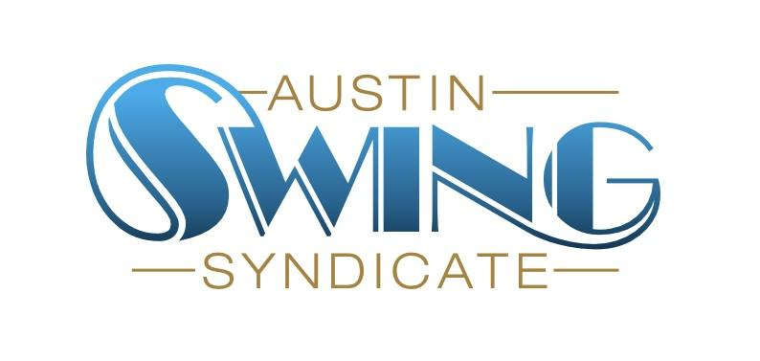Austin Swing Syndicate, Inc.

[board@austinswingsyndicate.org](mailto:board@austinswingsyndicate.org)

1108 Lavaca St. STE 110-273

Austin, TX 78701-217

**Board of Directors Meeting Minutes**

May 29, 2024

Present: Lon, Emory, Jen Reed, Joanna, Nick Williams, Phil

### May 30 contest

* First band break at 10:00
* 3 songs, all al-skates
* Song 1: everyone on the floor
* Song 2: everyone on the floor, 5 judges will select 1 couple each
* Song 3: Final round, judges will choose a winner
* Prizes: 1 month class voucher, t-shirt and 2 free admission cards (for each person)
* No board members or instructors allowed to enter (applies to both ballroom and series instructors)

### Classes

* Finances
  + ~4 people in a class is break-even
* Survey findings and feedback
  + People are unsure of what classes are available, what the skill level for each class is and what will be learned in each class
* Joanna brought up that we do not have any teacher meetings to discuss pedagogy and give our instructors a chance to learn from each other
* Action items
  + Jen and Emory to start auditing some classes
* What to do for the Lindy Plus slot for June (7:00 time slot)?
  + Choices: open practice or solo jazz
  + Jen is going to see who she can get to staff one or the other and that will determine which option we go with