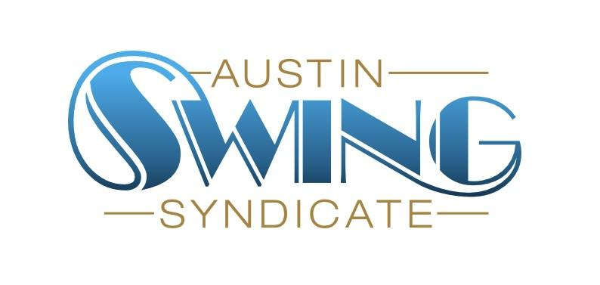Austin Swing Syndicate, Inc.

[board@austinswingsyndicate.org](mailto:board@austinswingsyndicate.org)

1108 Lavaca St. STE 110-273

Austin, TX 78701-217

**Board of Directors Meeting Minutes**

April 18, 2024

Present: May, Sam, Phil, Nick, Lon, Emory, Jen, Joanna, Whitney

### Volunteers

* Volunteer party budget: “mehhhhhh, a couple of pizzas”

### Live music

* Hot Toddies wants to play 7/18
  + Approved by Vote
* Golden Hour wants to play on 8/8 -> this would be the Anniversary dance
  + Approved by Vote
  + Jen D will be making a graphic for this
* September would have the Back to School dance/event but not a live band
* UT Jazz band wants to come back sometime in October
  + Nothing confirmed yet

### Training docs

* Phil is going to move all the training docs into a single folder
  + There will be a separate folder for Treasury specific instructions

### Hardware

* Old square reader is working but not the best
* **Action Item**: Nick to find some options for square readers

### Blues sideroom

* Will the Blues board provide someone for setup and teardown every night?
* What weeks work? 1st and 4th work easy, 2nd and 3rd would require shifting our taster class schedule
* Trial run will be 4th week of June, 1st and 4th week of July
* Will have more permanent answer in August
* DJs will be paid during the trial run

### Tables in ballroom

* When should tables be setup?
* Moving discussion to Slack

### July 4th

* Not enough instructors to staff full time series classes
* July classes will go into the 1st week of August
* Ballroom class will still happen
* Volunteers can start setup at 7

### 

### Blanton event

* Can we get a discount for our dancers to go?
* We need to bring some of our own advertising material to that event