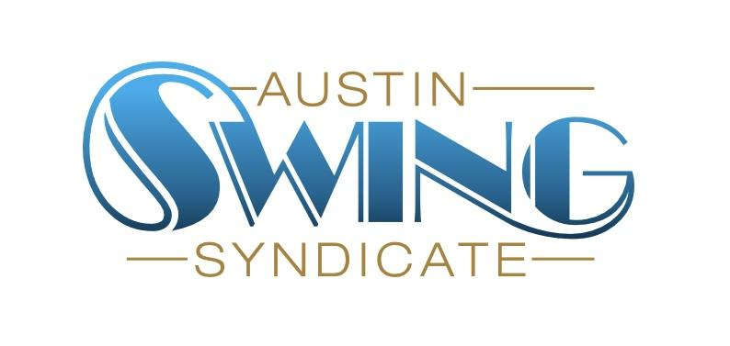Austin Swing Syndicate, Inc.

[board@austinswingsyndicate.org](mailto:board@austinswingsyndicate.org)

1108 Lavaca St. STE 110-273

Austin, TX 78701-217

**Board of Directors Meeting Minutes**

July 11, 2024

Present: Phil, Sam, Nick, Lon, Emory, Matt K, Chris G, Deb, Joanna

### Heading 3 (Ctrl + Alt + 3)

* Normal 11 (Ctrl + Alt + 0)

### Goals and Priorities

* Action Item: [emory@austinswingsyndicate.org](mailto:emory@austinswingsyndicate.org) is going to put together a survey to take a pass at gathering goals and priorities information

Hot Toddies

* So far everything is on track

Anniversary Dance

* Phil: “GH is aware of it”
* On 8/8, Glass Elephant is going to do recording for that night
* Action item: [phillip@austinswingsyndicate.org](mailto:phillip@austinswingsyndicate.org)is going to reach out Jen D about a graphic

### Equipment

* New Square chip reader. May to put together docs for how to use it and where to put it

### Blues side room

* Trial program in July in progress (tonight is first night)
* Pending no issues on 7/11, Sam motions to continue 2 per month side rooms on 2nd/4th weeks through September (except when we cannot use the venue). Nick seconds. Passes unanimously

### Venue displacement

* Options
  + Life in the City
    - Cheaper but will require more work from the Syndicate (we will have to provide speakers)
  + Sangerrunde

### Summer workshops

* Up and running, will continue running until we decide to end the workshops, probably through September

### DJ event proposal (there are proposals for these with more details)

* “Swing through the ages” event (Phil/Lon)
* “Request night” event (Phil/Lon)
* “Soul night/hour” (Joanna) (no formal proposal for this)
* Going to move all 3 of these to Slack to work out details

### Marketing budget

* Phil has some plans (marketing on radio, working with SEO friend of Vic’s)
* Moving to Slack where Phil will put more detail in to a formal proposal
* Budget would be $3000-$4000
* Phil motions to give Jen D a sustaining membership. Passes unanimously