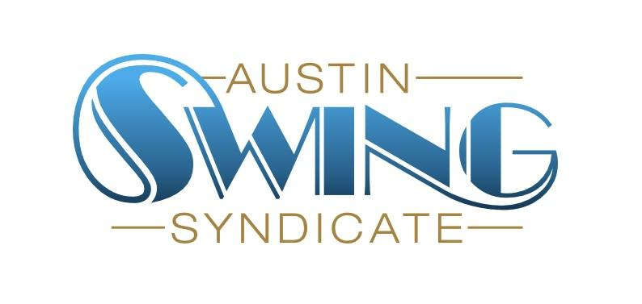Austin Swing Syndicate, Inc.

[board@austinswingsyndicate.org](mailto:board@austinswingsyndicate.org)

1108 Lavaca St. STE 110-273

Austin, TX 78701-217

**Board of Directors Meeting Minutes**

April 18, 2024

Present: Sam, Emory, Nick, Jen, Phil, Lon, Cailin, Jake, Joanna, May

### Class Survey Feedback (Cailin)

* <https://docs.google.com/presentation/d/1DflQOvuJU2NSOt7zahNAbkV-dn9Z_O9Ta2bgpGnSEpU/edit#slide=id.g26e5ddcbbd0_0_30>
* Asks for the board
  + Review feedback and survey and give feedback to Cailin and Whitney
  + Approval to have teachers ask students to take survey at end of last class of the month (general approval given)
* Future plans
  + Do interviews to get into the “whys?”
  + Get in touched with new dancers (ex: not taking classes yet)
  + Provide incentive for people to give feedback
* **Action item: someone needs to print QR codes for April 25th classes** 
  + Joanna volunteered to do this

### Volunteers

* Everything is good overall
* Slight dip in number of volunteers over the past month, no need to worry though
* **Action item: Nick and May need to get the free-class cards for volunteer perks program**
* We are deleting the Volunteer Orientation FB event. Orientation will go through May :)

ALX

* Victor is in on Friday
* Lauren said probably in but asking about more money (sticking to 10 person band)
  + She said they make $300/person for Lindyfest
* Getting committee members and volunteers is an initiative for next month
* **Action item: find someone to organize a dance competition before big-d lindy**
  + Winners would get ALX passes

### Live Music

* Board needs to revisit how much we pay bands
* WCV confirmed May 30th
* Anniversary dance
  + Sometime in July with Golden Hour (depends on if/when we get Hot Toddies)
  + If on July 18th, cancel Band Jam
* Some community band leaders have asked about how live bands are chosen. It doesn't seem very transparent. Moving to Slack discussion

### Classes

* Board to set a special session to go into more detail, especially Plus content
* Need to send out a larger survey to get more info (Jen to work with Cailin on this)
* Will there be Plus in May?
  + No, will have a month of teaching the Big Apple instead
  + Performance on last week of May (5th week)

### Workshops

* 5th week of May
* $25 entry fee
* Kari & Thomas’ Int/Adv LH class (approved)
  + “Bridge class between Foundations and Core”
* Jen’s “Swing Sampler” (approved)
  + 30m Lindy, 30m, Bal, 30m Shag
  + Goal is to advertise what can be taken next month
* Tab’s Chorus Line routine (approved)
  + Open to anyone
  + Mini routine and info session (both part of workshop)
  + Would be on the landing

### Newsletter

* Need graphics for all upcoming events (WCV band, workshops, classes)
* Try to send out newsletter a couple days early since the 1st is a Wednesday

### Board meeting schedule

* There needs to be a meeting at the Fed that is accessible to all members.
* Nick proposes meetings on 2nd Thursday at 9 but keeping meeting short (fixed 30 minutes)
  + Needs to go in newsletter
  + Nick motions, Emory seconded, unanimous approval

### 

### Grants

* Cultural Art Grant ($5,000)
  + Jen is going to apply for this (board generally approves)
  + **Action item: Phil to get Jen the budget info needed**