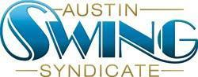
Austin Swing Syndicate, Inc.
board@austinswingsyndicate.org
1108 Lavaca St. STE 110-273
Austin, TX 78701-217

Board of Directors Meeting Minutes
November 29th, 2018

New Business:
- ALX Report
- NYE Update
- Marketing Update
- Upcoming Election

Meeting started at 8:00 PM.

Discussed (Outside of New/Old Business):

- ALX musician communication, payment, and housing.
- ALX Committee composition.
- Funding deadline and SurveyMonkey (“What would get you to come?”)
- Social media marketing.
- Contact ILHC coordinators.
- NYE manpower necessity
- NYE decor
- T-shirts on sale
- Budgeting for upcoming Live Bands, special events, so on.

