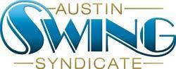

Austin Swing Syndicate, Inc.
board@austinswingsyndicate.org
1108 Lavaca St. STE 110-273
Austin, TX 78701-217

Board of Directors Meeting Agenda
Nov 29, 2018

New Business:
- ALX Report
- NYE Update
- Marketing Update
- Upcoming Election

